|  |  |
| --- | --- |
| Quiz Application November 2015 | Beni Iyaka  H00181266  4th year  Heriot Watt University  Mobile Programming and Communication |

Table of Contents

1.Introduction...................................................................................................................2

2. Summary of the technology used................................................................................3

3. Process followed ...........................................................................................................3

4.Application diagram…………………………….............................................................4

5.GUI screenshots…….....................................................................................................7

6.Bibiliograpy.. ................................................................................................................16

7.Source code………..........................................................................................................17

**Introduction**

Android is an operating system for mobile phones and tablets, in much the same way that PCs run Microsoft Windows as their operating system. It's maintained by Google, and comes in a few different versions. (Bolton, 2011)

Android devices come in all kinds of sizes, with all sorts of features, and at all sorts of prices. Each version of Android is named after a dessert. With Android, you’re in control of your mobile experience. (Android)

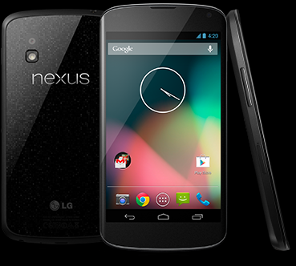

Figure 1 (Android)

The product I have created is a game application quiz activity; the quiz has five category questions.

The category questions being Mathematics, Life Science, History, Geography and Physical science; of which:

* Maths has three randomly generated questions.
* Life Science has three multiple choice questions manually inputted questions from the code.
* Physical Science has three multiple choice manually inputted questions from the ode.
* History has four multiple choice questions that are extracted from the XML file online.
* Geography has four multiple choice questions that are extracted from the XML file online.

**Summary of technology used:**

The technology used in terms of programming the application was the following:

* Java: this was used to create class and some programming style.

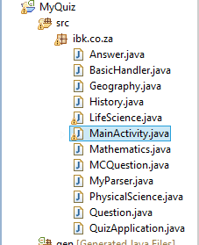

* XML: this was used to set up the style of which I want my application to have.

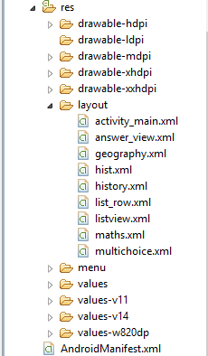

* Eclipse: this is the programming application I used to program the quiz application.

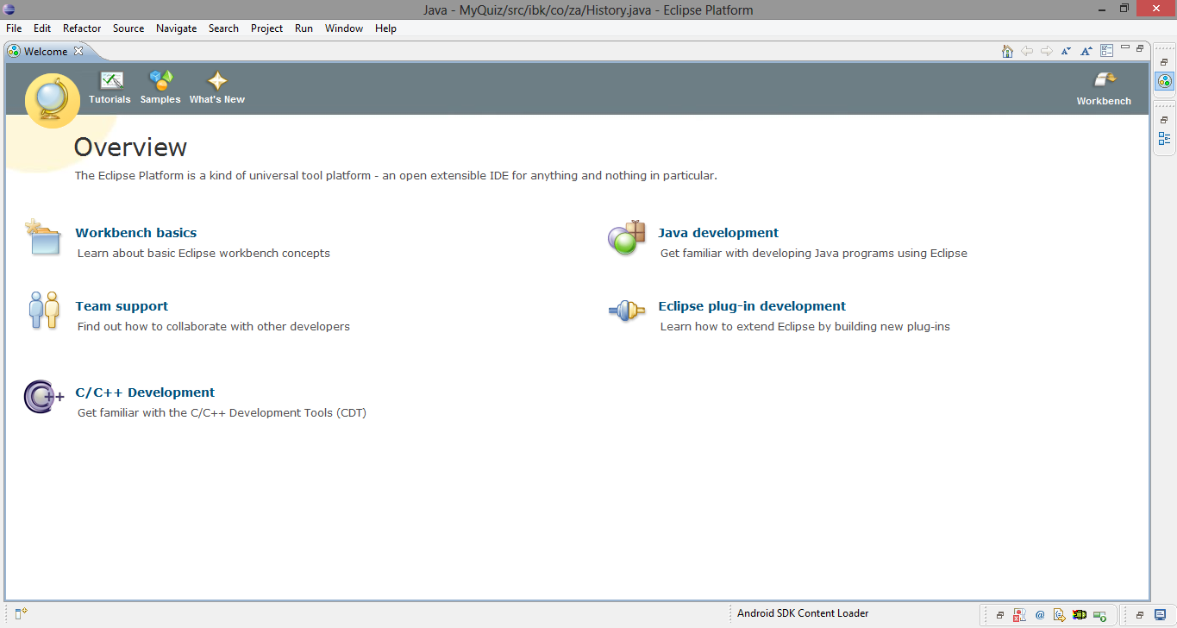

* Android- SDK: this is the kit that eclipse used to develop android applications.

**Application diagram**

Total Summary Attempt

Attempt and Score

XML Directory

History XML

Geography XML

Physical Science

Questions (3)

Multiple Choice Questions (3)

Maths

Randomly generated questions (3)

Life Science

Questions (3)

Multiple Choice Questions (3)

Quiz Application

* Maths
* Life Science
* History
* Geography
* Physical Science

**GUI screenshots**

This is the first form of the application, it permits you to select whatever category you decide in any particular order.

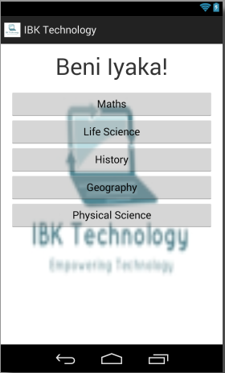

When you select the maths button, it takes you to this interface, to answer three random questions. And everytime you answer the question, there is a summary at the bottom to tell you how you did out of 3 questions.

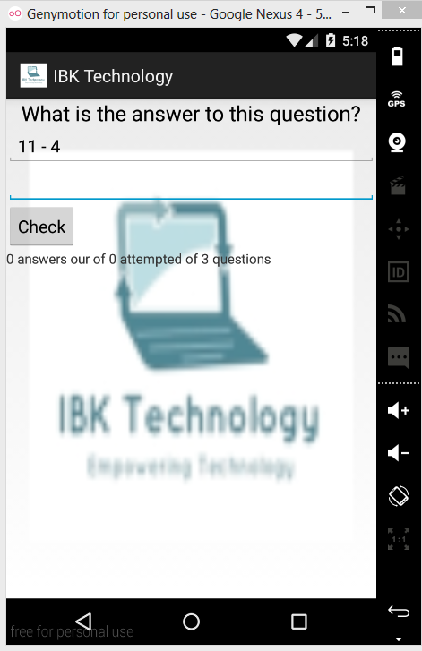

When you select the life science button, it takes you to this interface, to answer three questions. And everytime you answer the question, there is a summary at the bottom to tell you how you did out of 3 questions.

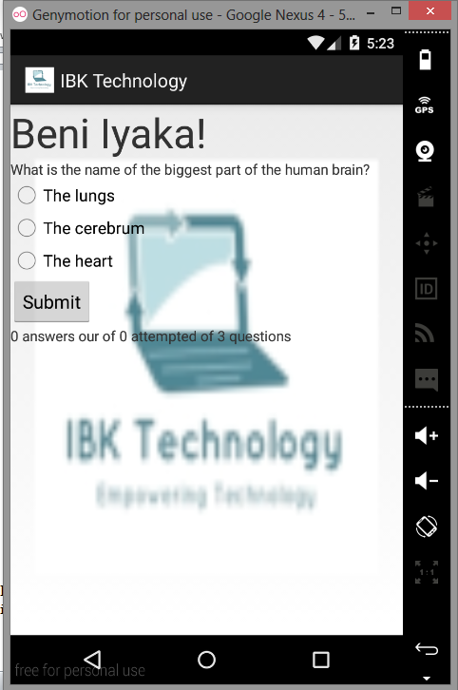

When you select the life science or the physical science button, it takes you to this interface, to answer three questions. And everytime you answer the question, there is a summary at the bottom to tell you how you did out of 3 questions. Due to the fact that I wanted to differentiate between questions that I have manually inputted in the code and the questions that are connected to the XML file from the directory, I went with 2 different types of layout and feedbacks, as you the following pictures showing the life science and physical science with a similar layout.

Life Science

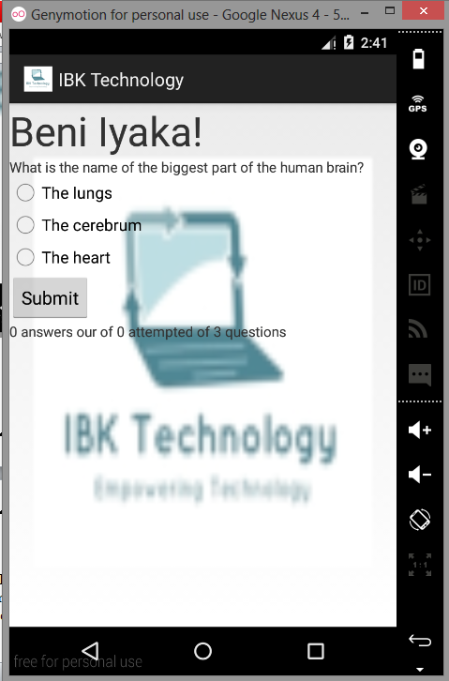

Physical Science

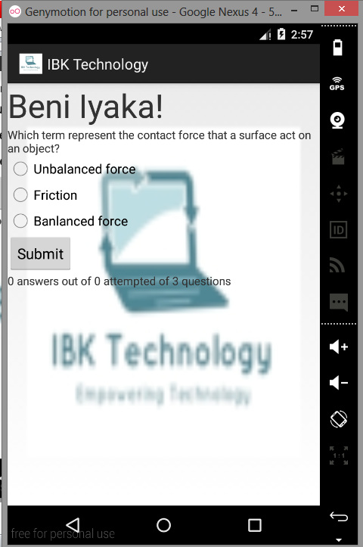

History and Geography

In these two questions category, I decided to use a different layout just to make sure that they can be easily differentiated. I used the layout where by the four questions are displayed to the player and once they select a certain question, then four optional answers will be displayed to them and one the select the answer, if it correct, then the question will be highlighted green and if it is incorrect it will be highlighted red and at the end, a summary form will appear telling them how they did. Below is the picture showing the History and geography form.

History

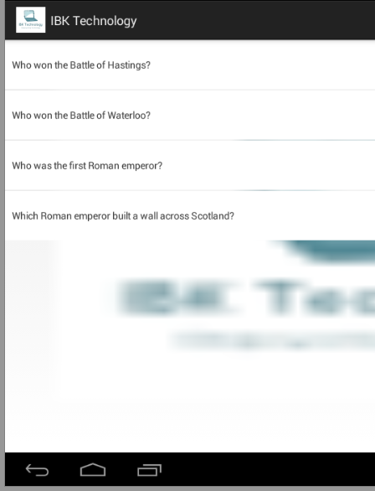

Geography

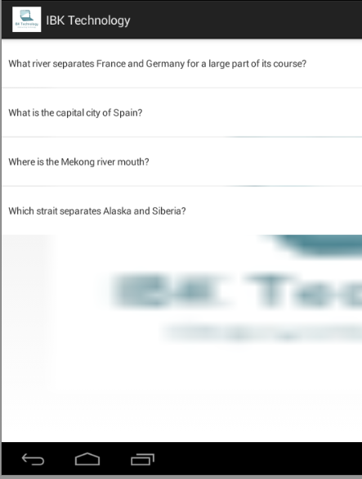

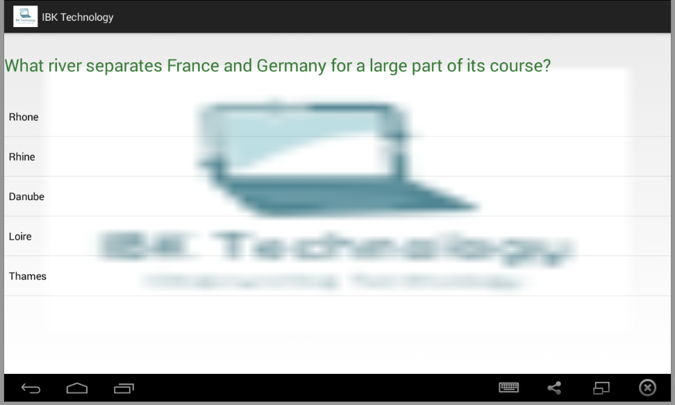

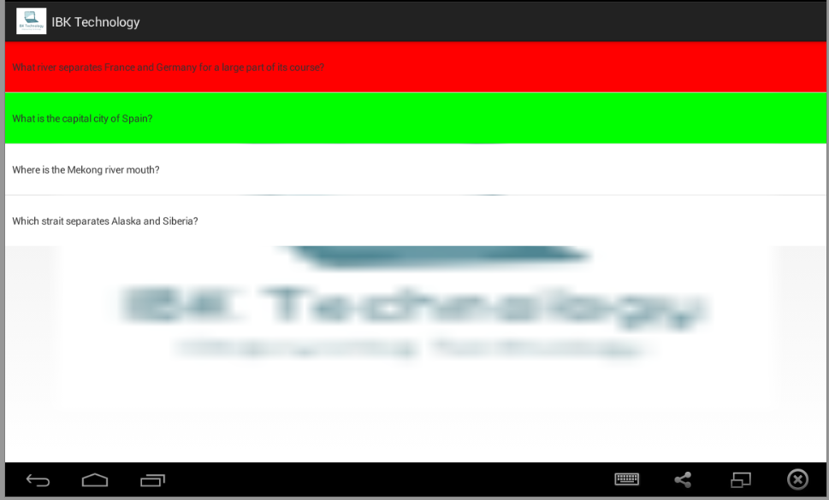

As it shows, the question that are answered correctly, are highlighted with green and the one that are wrong in red and the ones that are not answered yet, are left white.

At the end of the quiz, a form will appear telling you how you did in the quiz.

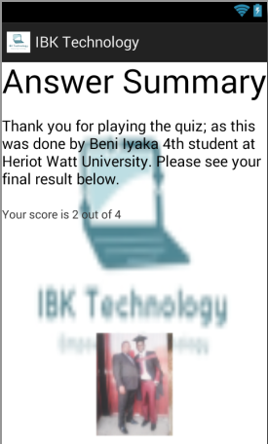

# Bibliography

*Android*. (n.d.). Retrieved 10 24, 2014, from Android: http://www.android.com

Bolton, M. (2011, 07 06). *What is android?* Retrieved 10 24, 2014, from Techractar: http://www.techractar.com

History.java

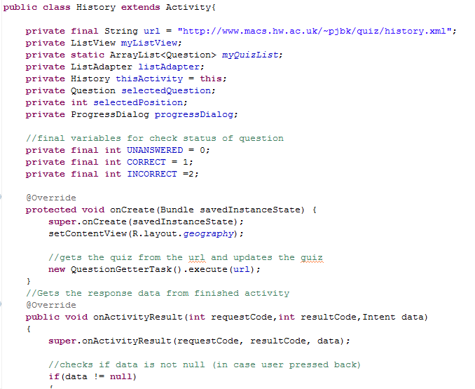

In the first line, I initialize the url of which we want to extract the questions from.

I initialize different component that I will be using to display answers and questions.

I set up the type of layout I want.

And I get the quiz from the url and update it each time.

